The Comparison of Bridge and Bregression

1. The Coefficients
   1. Bridge

* 1. Bregression

1. The Alphas
   1. Bridge

* 1. Bregression

1. The Gammas
   1. Bridge

* 1. Bregression

1. Betas
   1. Bridge

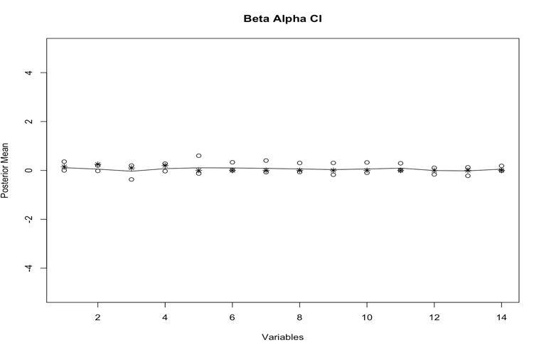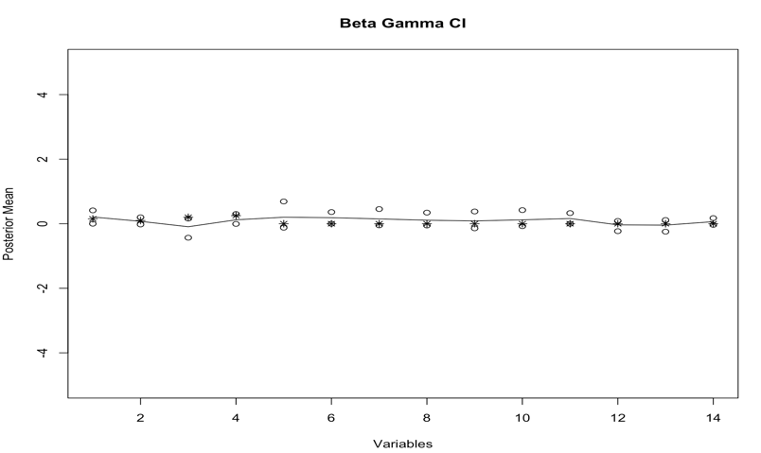

* 1. Bregression

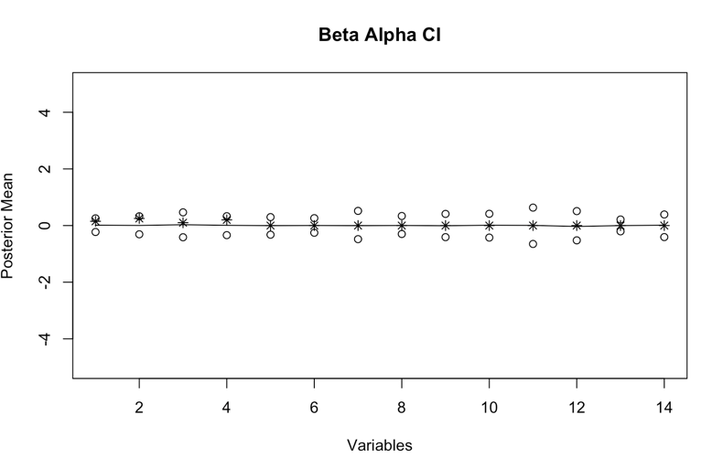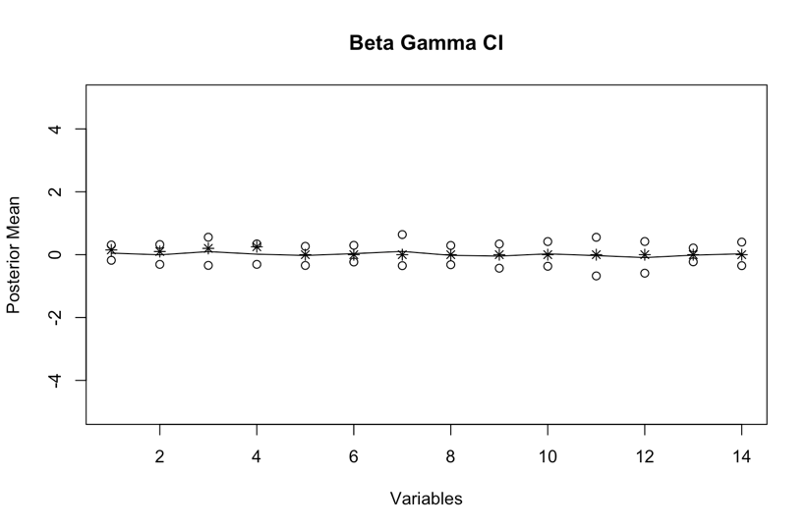

1. Prediction Y @ t=48
   1. Bridge

* 1. Bregression

1. Prediction Y @ t=72
   1. Bridge

* 1. Bregression

